

**Letter of Recommendation**

To whom it may concern,

I am pleased to write this letter of recommendation for Vanshika Chauhan for the Masters in Business Administration program at your esteemed University. I have been a mentor and a second line manager to her for ~2.5 years, since the day she joined our organization as an Associate Analyst. She had grown progressively within the organization and her last held designation was of an Analyst.

She is a very hard working individual who is eager to learn new things and apply it practically. Throughout her tenure she had taken multiple initiatives in terms of process optimization with end to end ownership. I was impressed with her persistence and frugality on streamlining the process SOP with limited resources by coordinating with various cross functional teams.

While we take pride in following a supportive work environment at Vaco Binary Semantics LLP, the general rigor and high standard of work is not for everyone. Vanshika however, has risen to each and every challenge as she is often recognized by the management for her work on various occasions and aspects. She logged in extra hours, devised necessary workarounds, and looped others in on the project to assist with some of the key issues that arose.

I have no doubt that Vanshika will be successful in your university and in her future career. If you would like any more information regarding Ms. Vanshika’s application, please do not hesitate to contact me.

​Thanks & Regards,

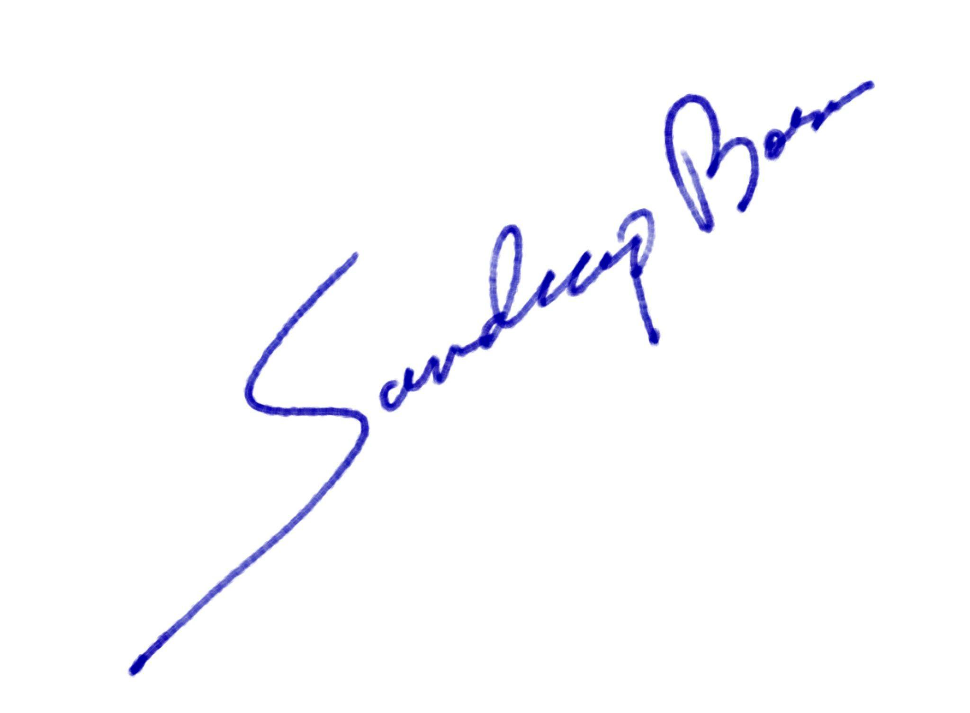

Sandeep Bose

Assistant Manager

Contact Number: +91-9711898078 | Email : [sandeepbose@google.com](mailto:sandeepbose@google.com)

*Services provided by VACO Binary Semantics LLP, on behalf of Google*

Feb 27, 2024